5.2 Progress Tracking

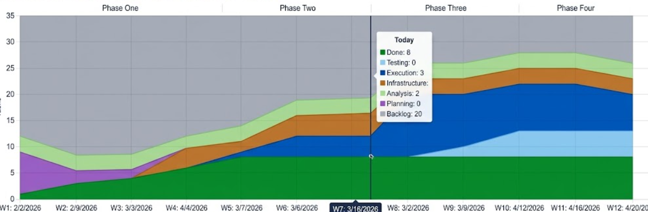

1. Process bottleneck: Since everyone can attend meetings at different times, there are certain time delays in the communication process, leading to some delays in plan handover.
2. Delayed start: Because everyone is unfamiliar with each other, gathering everyone and coordinating time with each other caused a delayed start.
3. Plan deviation: Regarding the diagram, there is a certain degree of delay compared to the plan we initially designed.

